How to setup S3 to Work with https protocol

# S3 WebClient Setup

1. Open the IIS on the server where you have hosted S3 Webclient
2. Right click on Default Web Sites and a context menu will appear.
3. Click on “Edit Bindings…”

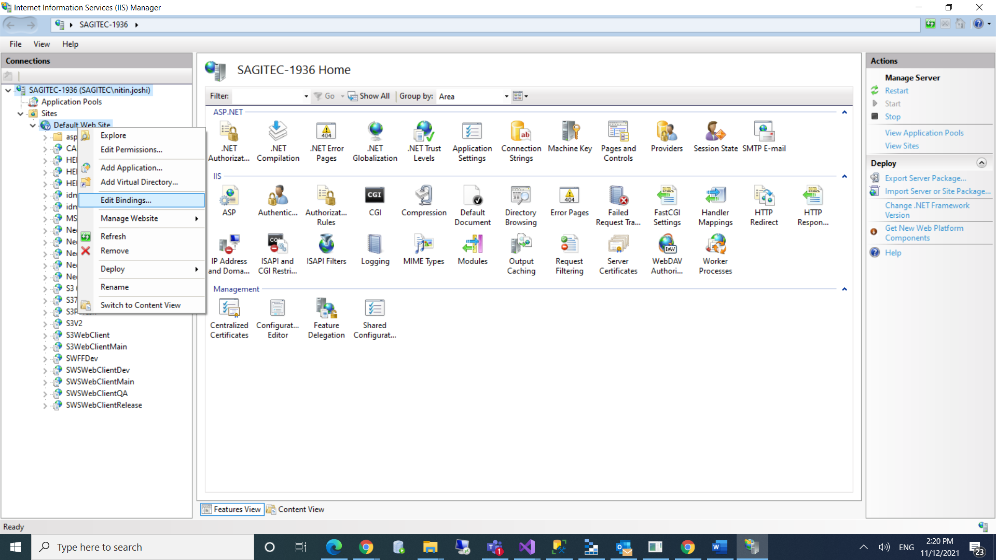

1. It will open a dialog where you can see the existing bindings.
2. If it doesn’t have the existing binding with port “https” then click on “Add” button.

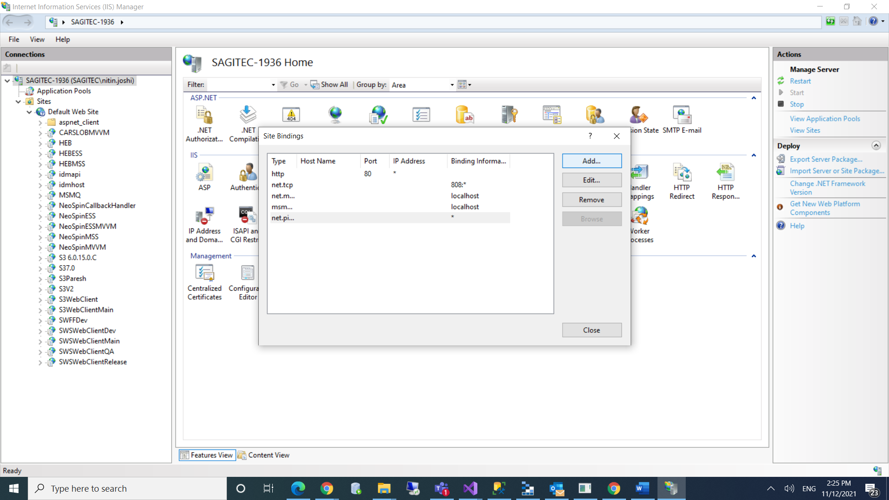

1. It will again open a dialog to add new binding.

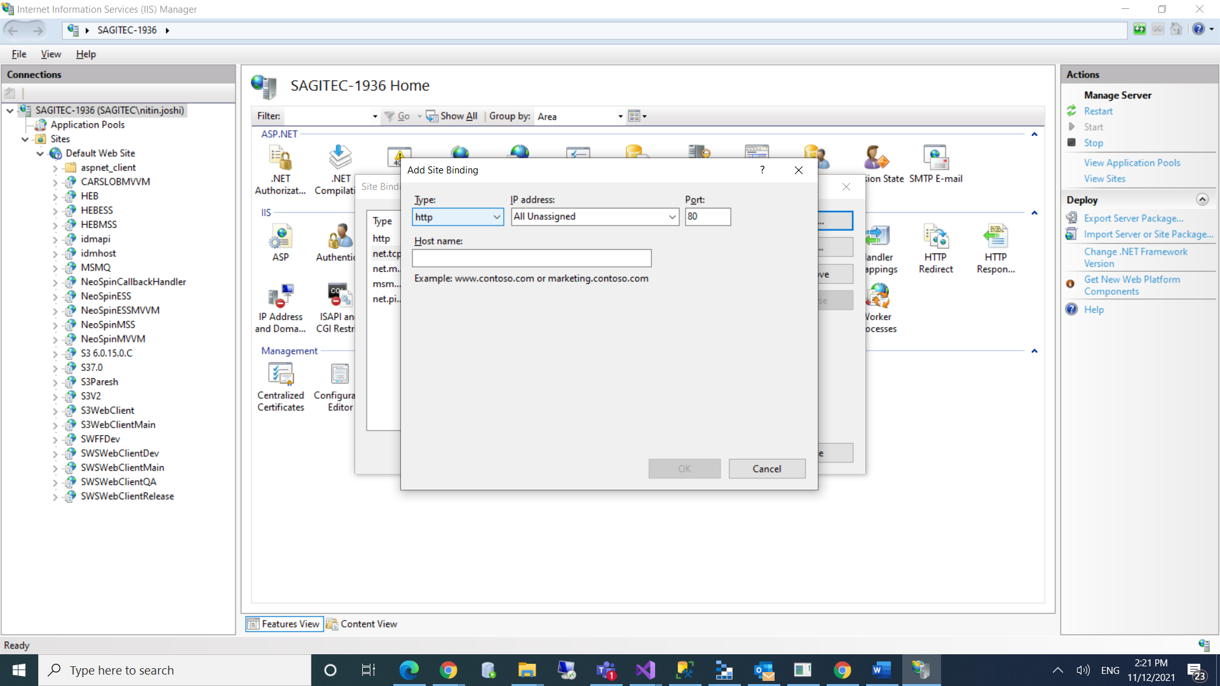

1. Select https from Type dropdown
2. Provide a host name which you want to use while accessing the url using https.
3. Select an SSL Certificate installed on the server.

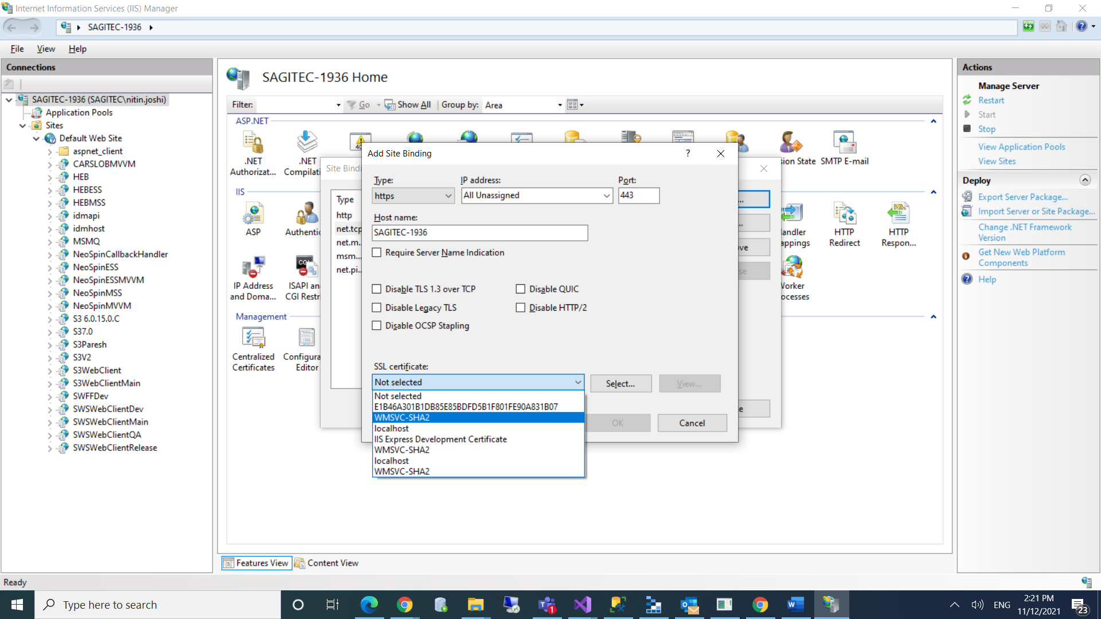

1. Click on OK button

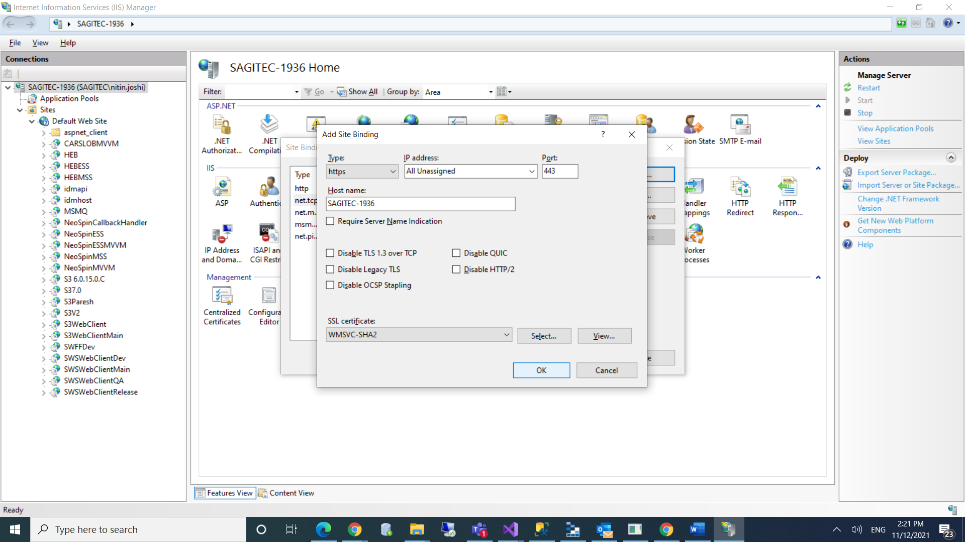

1. It will add the binding with https protocol.
2. Click on Close button.

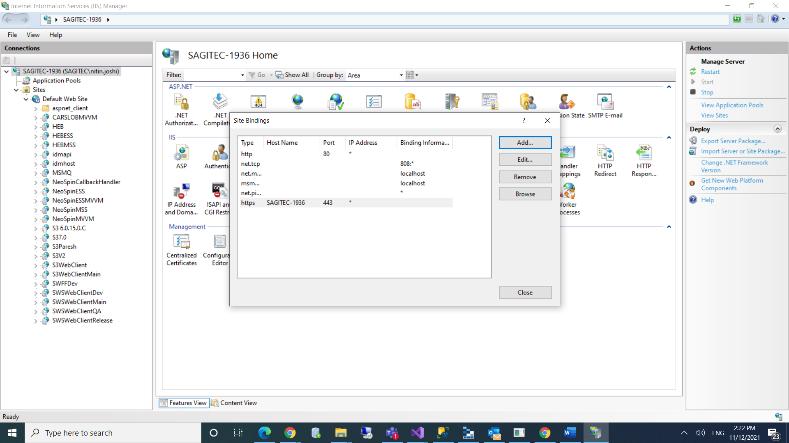

1. Restart the IIS
2. Setup is done, now you can access the S3 web client using https protocol.
3. While accessing the url you may get following error in chrome browser. If error comes then click on “Advanced” button and then click the highlighted link in second screenshot below. The link text may be different as per your web application name.

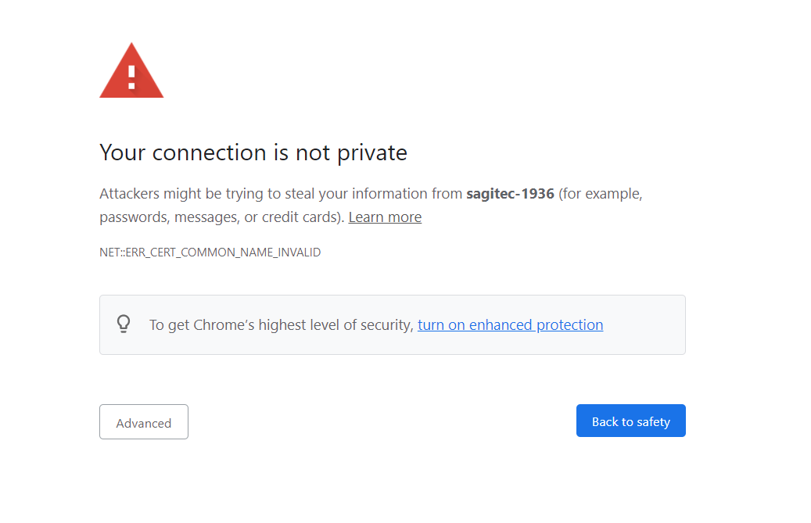

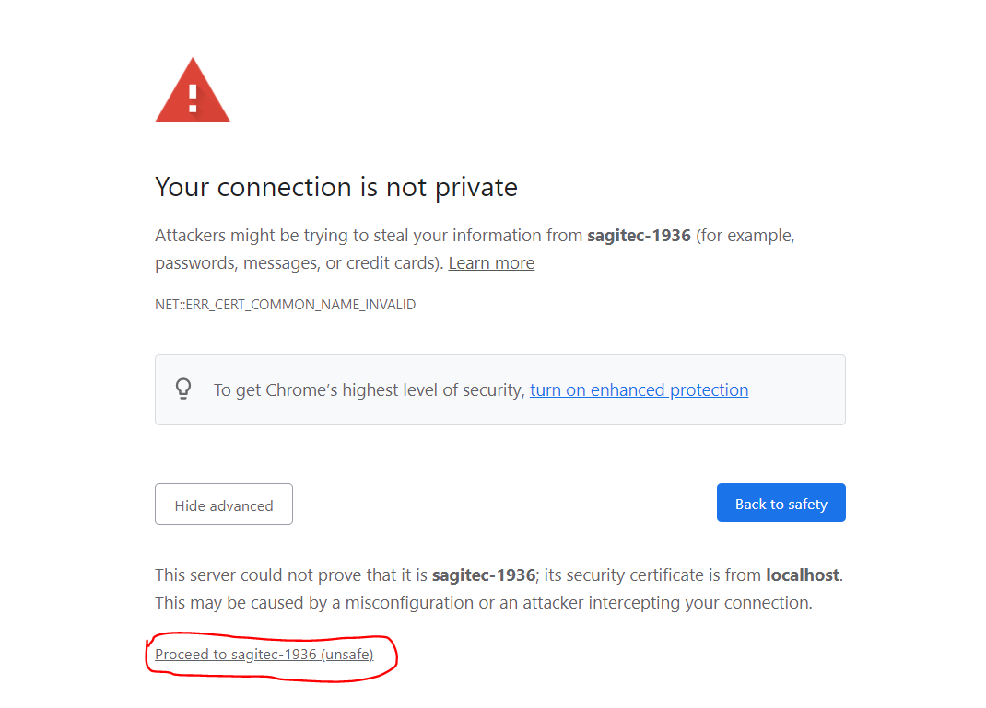

# S3 Signalr Host Setup (6.0.18.0 or higher version)

1. Run S3 Signalr Host **(6.0.18.0 or higher version)** and check if S3 web client is getting connected to Signalr Host or not.
2. If it’s not getting connected, then click “Install Certificate” or “Re-Install Certificate” button on S3 Signalr Host UI.
3. It will install/re-install the local ssl certificate and restart the Signalr Host.
4. After Signalr host gets restarted, reload the S3 web client and it should get connected to Signalr Host.

# S3 Signalr Host Setup (Older version than 6.0.18.0)

1. Shutdown your older Signalr Host if running and run latest S3 Signalr Host **(6.0.18.0 or higher version).**
2. Click “Install Certificate” or “Re-Install Certificate” button on S3 Signalr Host UI.
3. It will install/re-install the local ssl certificate and restart the Signalr Host.
4. Now close the latest Signalr Host.
5. Remove below key from “SignalRSelfHost.exe.config” file of your older Signalr Host.

<add key="HttpsHubPort" value="8083" />

1. Run your older version of Signalr Host and reload the S3 web client and it should get connected to Signalr Host.